Task 1:

I used the similar format that can be seen in the highlighted GET url in the screenshot below for ‘sendurl’ variable in my 1905033_Task_1.js file. I got it while adding charlie as a friend of alice. The screenshot is added below:
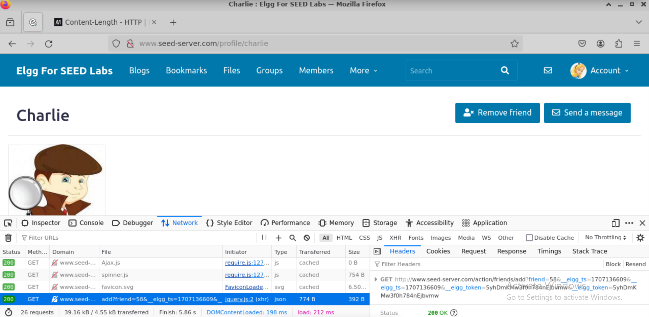

I needed to know the id of samy to add it in ‘sendurl’ and to add a condition in my script so that samy himself does not get affected by the script embedded on his profile. From the picture below I got to know the id of alice, which is 56.
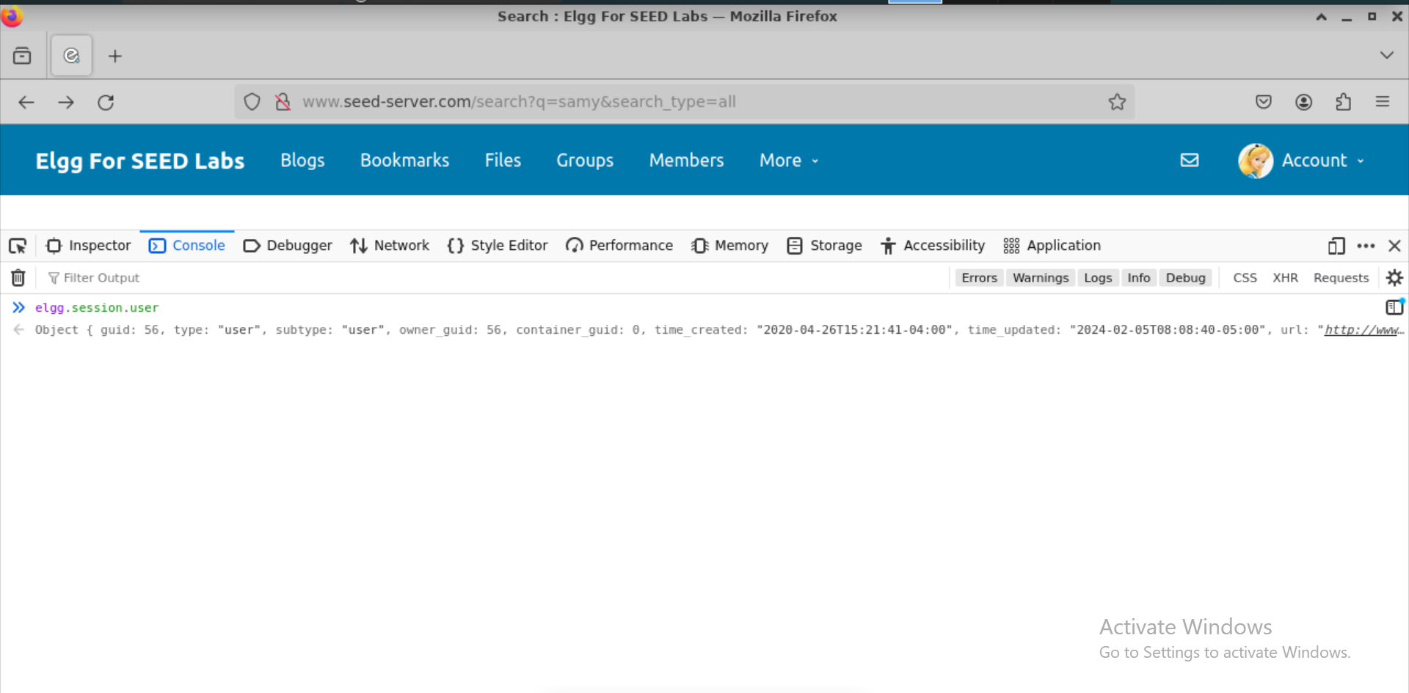
I noticed that arranging the members' names alphabetically coincides with a sequential increase in their corresponding ID numbers. I took an educated guess that samy’s id is 59. My guess turned out to be correct after adding him as a friend of charlie for test purpose.
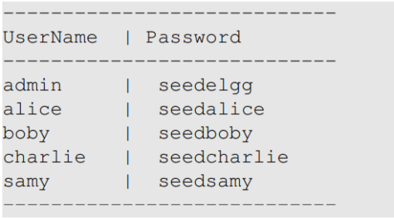

Task 2:

I got the url for updating the profile from the screenshot below:
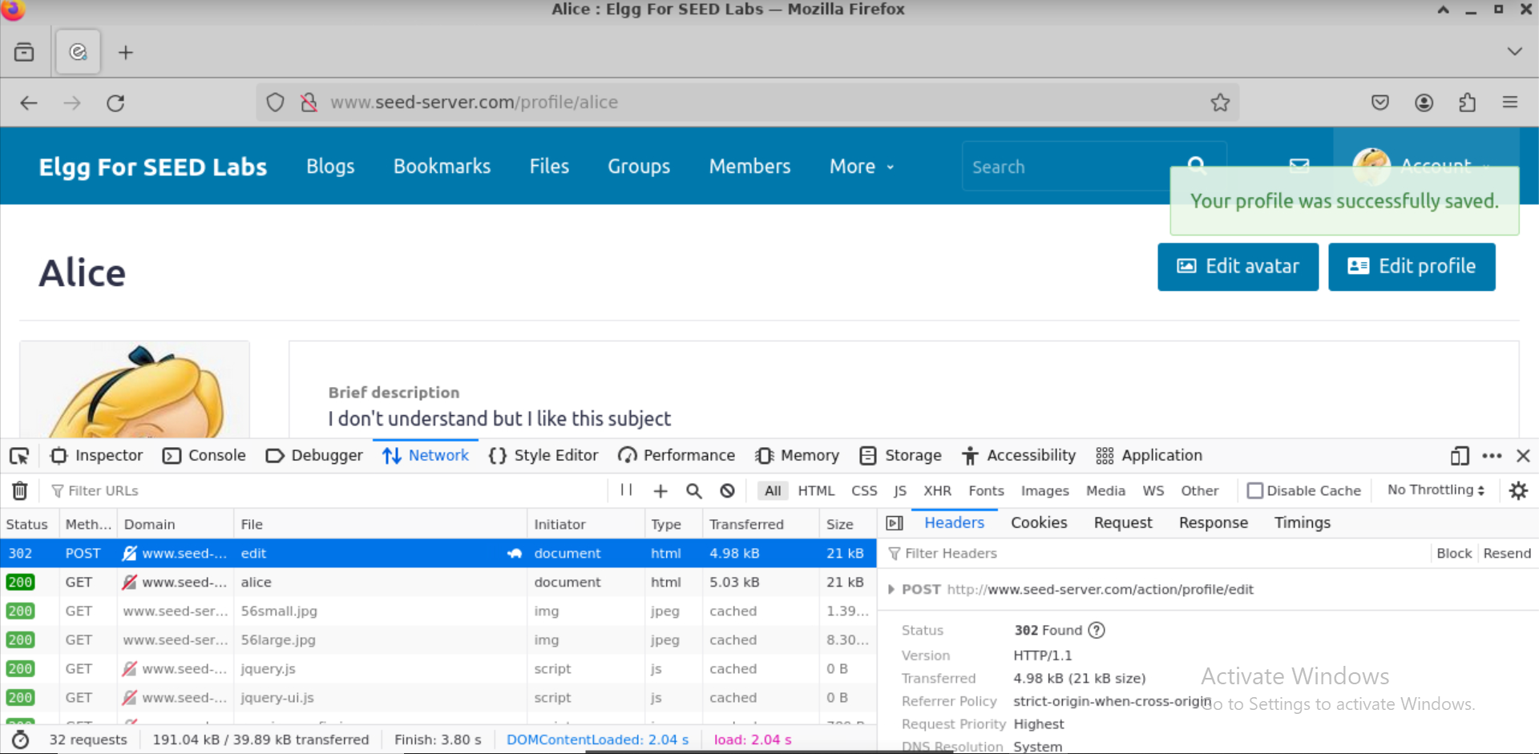

For the ‘content’ variable, I searched the content format for application/x-www-form-urlencoded and got the following format:
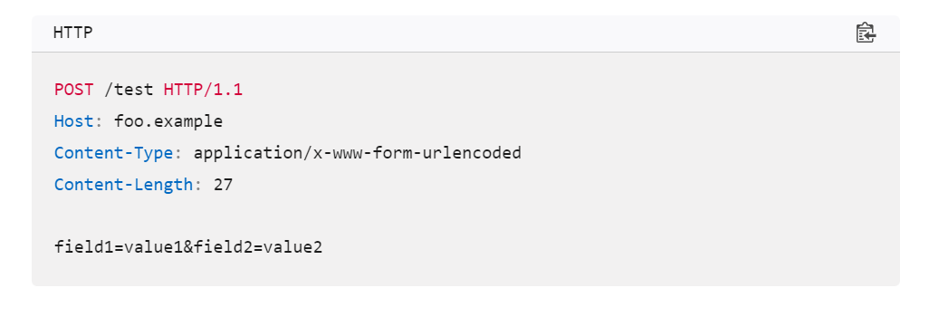

I got the necessary fields for content and the access level id for ‘logged in users’ from the following screenshot:
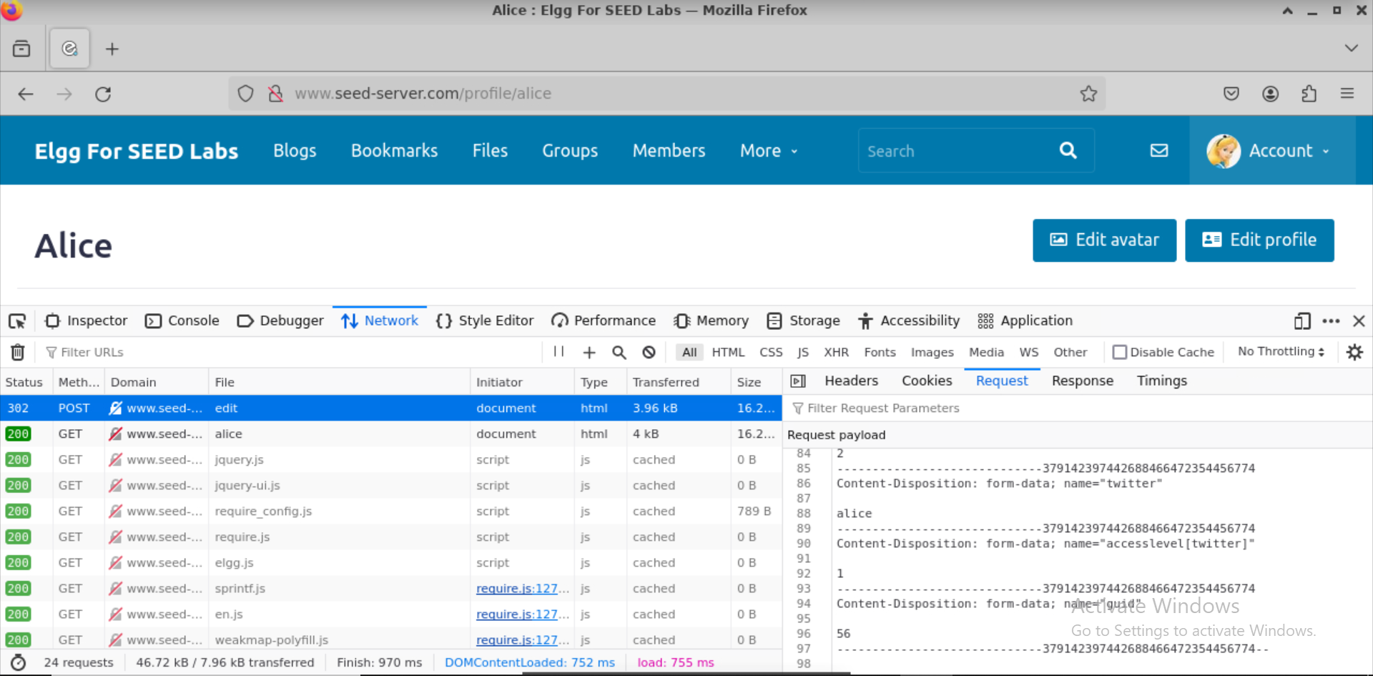

Task 3:

I got the url to wire post from the highlighted url in the screenshot below:
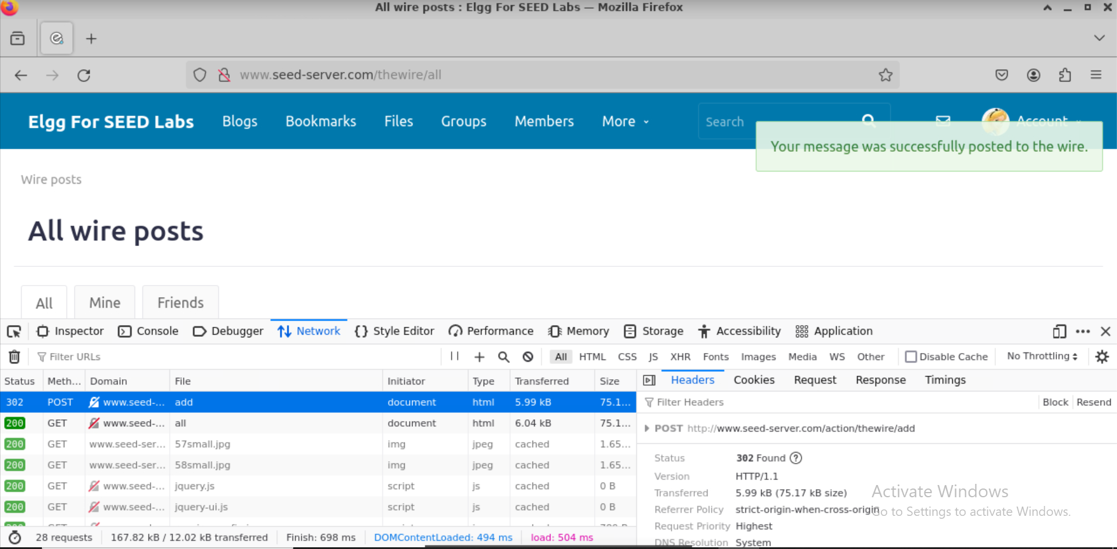

For the content, I followed the same content format as in task 2.

I got the necessary fields for content from the ‘request’ portion of the same highlighted url:
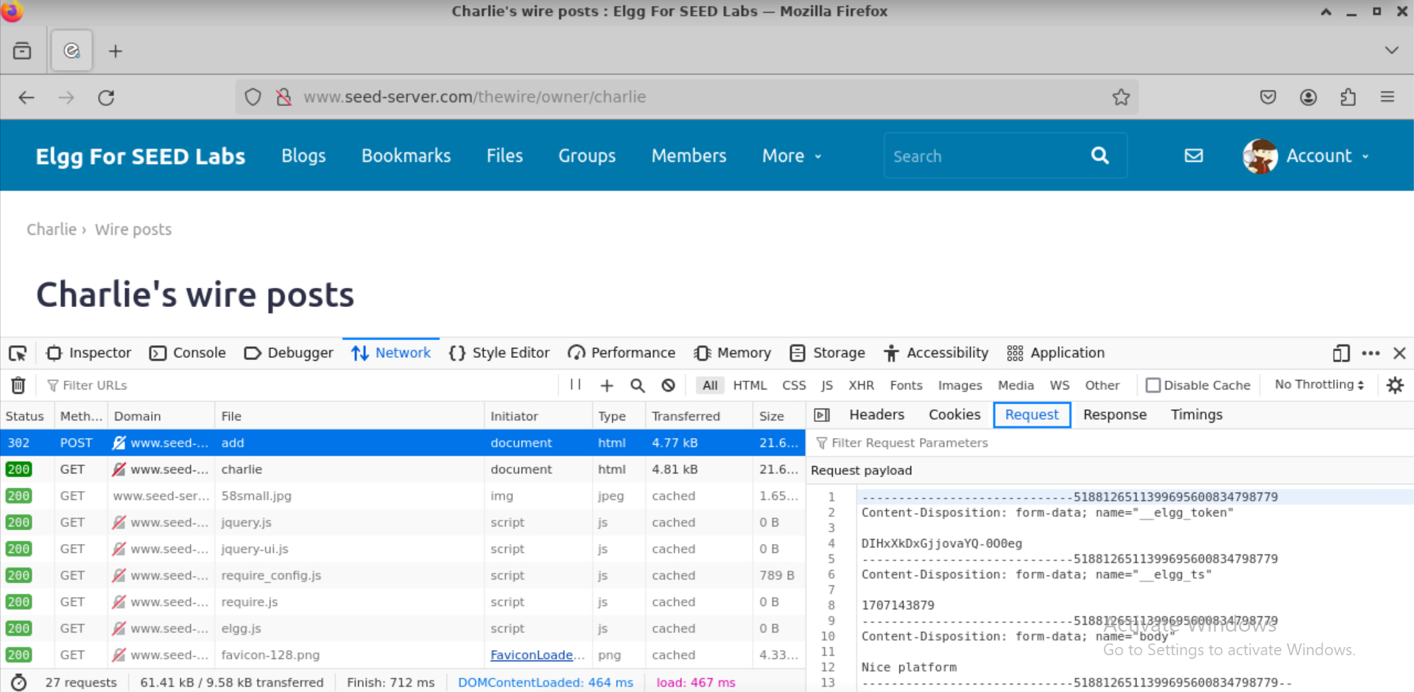

Task 4:

I used the provided DORM API example for retrieving worm copy. For this task, I assembled all the work of task 1, 2 and 3 and an additional worm code that replicates itself in the victim’s “About me” field.

